 | Application Form MS-Word Template

Executive summary of the proposal

Title*: Development of Ambient Stable, Exploratory and Cost-Effective Perovskite Quantum dots for Next Generation Flexible Photonic Applications.

Domain of research*

Summary of the project* (max 1000 words) (State the problem, strategy opted to solve the problem, including the potential translational and societal (Indian) impact. Mention the novelty and interdisciplinarity (if any):

Organic-inorganic halide perovskites(HPs) have emerged as a promising material attracted significant attention due to their superior properties, such as suitable narrow direct bandgap[1] , high extinction coeﬃcient[2], colour purity, low Urbach energy[3], small Stokes shift[4], long charge-carrier diﬀusion lengths, high charge carrier mobility, high photoluminescence quantum yield (PLQY), solution processability and low Wannier−Mott exciton binding energies conferring perovskites a tremendous potential in the field of optoelectronic and electronic devices[5]. The eﬃciency of perovskite solar cells has risen dramatically from 3.8% to over 22% which is comparable to polycrystalline silicon solar cell in the past several years owing to concentrated eﬀorts on the optimization of perovskite layers and device structures, interfacial engineering, and so on. Nanocrystals (NCs) have emerged as a new generation of low-cost semiconducting luminescent system with unique photonic and electronic properties.
Among these materials halide perovskite NCs (HPNCs) have dawn extensive attention. Beside low cost and facile synthesis process, the band gap of perovskite QDs can be conveniently tuned through controlling the halide composition, quantum confinement effect covering the whole visible spectrum from 400-800 nm. Compared to conventional metal chalcogenide QDs (CdSe,CdS, etc), halide perovskites QDs show elevated photoluminescence quantum yield (PLQY)[6]. HPs NCs are suitable in photovoltaic due to a combination of their high-quality optoelectronic properties which are size dependent, inexpensive fabrication costs and ease of processing.
HPs QDs possess the potential of harvesting the wide range of solar power. They possess the potential for efficient optoelectronic application due to their quantum confinement effects. Though the multiple charge generation with wide range utilization of solar power for efficient conversion to electricity. HPs QDs are interesting due to the observed large exciton binding energy, well self-passivated surface, as well as the enhanced nonlinear properties. They also possess high photoluminescence quantum yields, size tuneable optical bandgaps and ultra-narrow band emissions, the combination of these superior optical properties and low-cost fabrication makes them to be suitable candidates for display technology (LEDs). Compared with bulk materials, the quantum yields (QYs) of HPs QDs reach up to 90%, making them particularly attractive for display application. Based on the size of the QDs energy bandgaps can be tuned so, it is the powerful tool to tailor the physical properties of semiconductors toward new generation functional devices.
Although the HPs NCs possess great potential, there are several barriers regarding stability (thermal, moisture and photo), fabrication, interface engineering, carrier mobility, eﬃciency, electronic coupling between nanocrystals and concern associated with potential environmental impact due to the lead (Pb) content need to be addressed to use them effectively in solar cells and LEDs to commercialize.
By proper control over the HPs crystal quality and dimension the good chemical and phase stability can be achieved. Developing new compositions that could oﬀer better structural stability and narrow energy band gap are required. There is a need to suppress the photoinactive yellow-phase impurities (hexagonal δ-phase) and the residual cubic PbI₂ phase (In Pb based perovskites) to obtain efficient perovskite material. In recent days doping is chosen as best strategy to gain structural stability and to fine tuning the band gap to absorb the major part of the spectrum.
Mainly template-based perovskite nanocrystals in mesoscopic architectures and solution processed nanocrystals (colloidal nanocrystals) are used in solar cells and LEDs as active layer or as an addition layer on thin film to boost the performances of the devices.
Template-based synthesis of perovskite NCs is a heterogeneous nucleation approach that oﬀers a facile, noncolloidal, and ligand-free NC preparation route. The porosity of the titania (meso-TiO₂) template permitted the formation of nearly monodisperse NCs measuring 2−3 nm in diameter, which acted as the sensitizer in the solar device. ability of perovskites to act not only as a light absorbing material but also as a charge-transporting material[7]. Accordingly, mesoporous scaﬀolds for template-based perovskite NCs can be categorized as active if they participate in the photoconversion process (e.g., TiO₂ and NiO) or as passive if they act purely as supporting scaﬀolds without contributing to the charge-transport process (e.g., Al₂O₃, SiO₂, and ZrO₂)[8] (figure1).
As a variety of methods for preparing solution-processed (colloidal) HPs NCs and QDs have become well-established. Ligand-assisted reprecipitation method (LARP) that relies on changing solvent polarity by adding a miscible antisolvent to initiate rapid perovskite nucleation in solution at room temperature. The utilized capping ligands enabled the dispersion of these monodisperse perovskite NCs in a wide range of organic solvents, which is advantageous for the design and fabrication of optoelectronic devices. Various other techniques to synthesis HP NCs are hot-injection method[9], continuous-ﬂow synthesis in single-phase[10] or two-phase[11], ion-exchange based reactions[12].

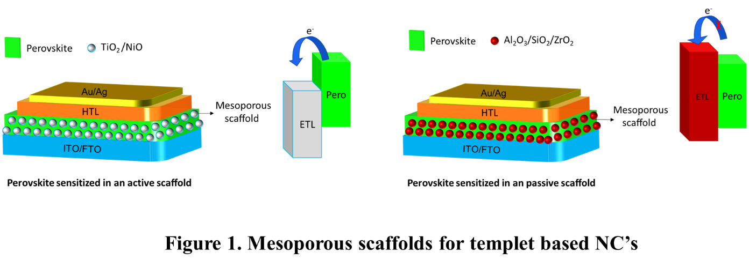
Conventional inorganic QDs have been demonstrated to retain functionality upon mechanical deformation in flexible devices. In this regard, colloidal perovskite QDs are well suited for the fabrication of efficient future of flexible electronics (figure 2). The development of perovskite devices based on these QDs mitigates issues commonly found in devices based on perovskite films such as low flexibility due to thick active layers and large grain sizes, a limited device architecture due to very polar aprotic solvents used for deposition of the active layer, and a cumbersome fabrication process. As an alternative route to the fabrication of efficient perovskite devices HPs QDs can be utilized in place of perovskite films. Perovskite QDs can be processed into thin solid films in nonpolar solvents and have shown enhanced PL properties, a broadened scope of device architecture, and promising device performance. 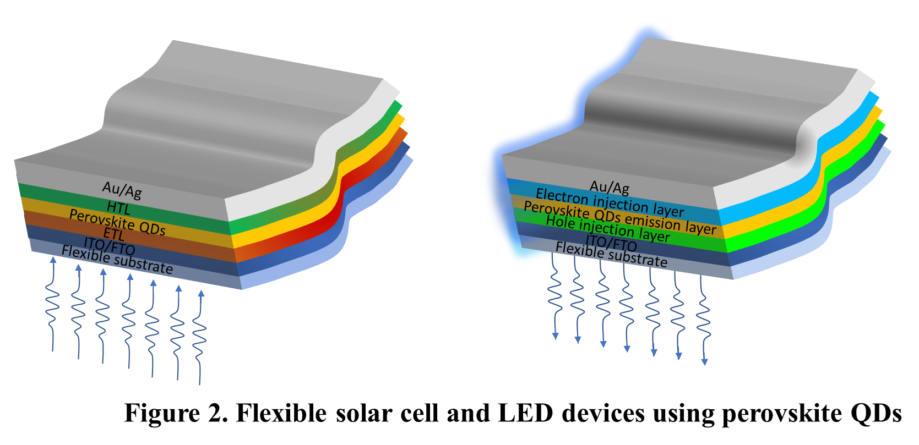
The present proposal aim is to develop flexible devices with the possible new combination of perovskite NCs. The defects, probably vacancies and/or distorted octahedra, could act as trapping centres of photogenerated carriers, thus giving rise to poor PLQYs for the band-edge emission. These defects form localized defects states (deep within the band gap) which trap charge carriers and leads to the formation of indirect band gaps, which inhibits the various optoelectronic processes. Hence the defect tolerant nanocrystals synthesis is paramount for high-efficiency perovskite QDs light emitting diodes, there is the need of judiciously selected foreign ion into the PeQD’s matrix that could increase the defect formation energy, thus reduce the defect/trap states[13].
Limited short-circuit current density (J_{SC}), which is a common trade-oﬀ in QD-SCs attributed to the presence of capping ligands that cause high electric resistance[14].With the possible strategy by replacing these long ligands (usually oleylamine (OAm) and oleic acid (OA)) which with shorter ligands through surface treatments without degrading or destabilizing the QD films still the bottleneck challenge obviating its use.
Optoelectronic quality of perovskites devices can be improved by interfacial engineering, that provides a path for suppressing recombination/carrier losses by introducing interlayers as additive.
Summary of the project file (pdf only) : <<Keep your file ready >>

Problem statement (The goal of the STARS program is to take stock of an existing problem and work backward towards conducting scientific research for a solution. Mention how the proposed project satisfies this criterion in less than 300 words.):

Numerous approaches have been proposed to improve the performance of PeLEDs and solar cells. Despite the considerable improvements have been accomplished, the overall EQE and efficiency are still low. Despite of all the superior properties, perovskite quantum dot devices are struggling with stability of the perovskite material, fabrication of device, interfacial engineering, carrier mobility, efficiency, electronic coupling between the nanocrystals.
Based on studies to commercialize the devices of perovskite quantum dots there is a need to address issues related to composition of the QDs, additives, deposition methods, a broad range of device area and selective charge extraction layers. Doping of elements can improve stability and performance of the solar cell if the tolerance factor is optimum. So, doping of specific element can give rise to specific band gap and stability to that materials.

$$t= \frac{(r_{a} + r_{x})}{√2(r_{b}+ r_{x}) }$$
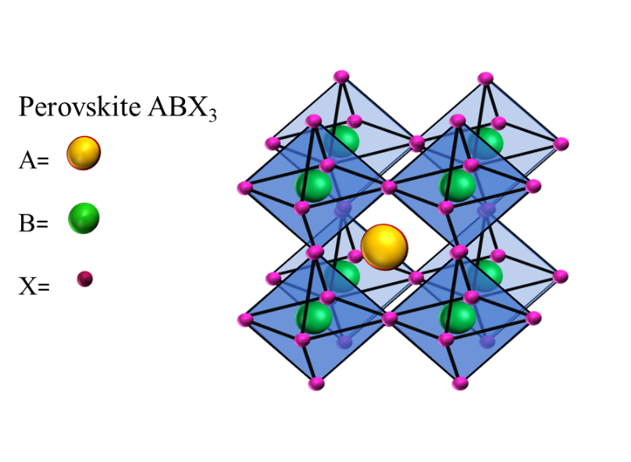
Figure 3. Schematic perovskite structure
Solar cells: By fabricating heterojunction bilayer solar cell which has both perovskite thin film and perovskite QDs as the active layer increased the efficiency when compared to separate individual solar cells of PeQDs and Perovskite thin film. So suitable band offset materials have to be arranged to obtain high photoconversion efficiency. Need to seek lower perovskite bandgaps, which are more suitable for single junction solar cells. Post treatment strategies of NCs improves the electronic coupling between the NCs, that increase the carrier mobility so hysteresis will be reduced. Stability and efficiency along with improved photovoltaic performance under enhance conditions based on advances in processing and interfacial engineering.

PeLEDs:The low light extraction efﬁciency which is caused by a large refractive index contrast between the active layer and charge injection layers which leads to poor optical confinement of the devise. The defects, probably vacancies and/or distorted octahedra, could act as trapping centres of photogenerated carriers, thus giving rise to poor PLQY for the band-edge emission. Long ligands do not enable feasible carrier transport in the QD film and ultimately affect the efficiency of device. Imbalanced injection of electrons and holes can be avoided by improving the carrier confinement in the device. To obtain good brightness and efficiency optimal dual confinement is required.

Keywords* (maximum five):
Electronic coupling, optical confinement, carrier confinement, defect states.

Objectives* (Short version: bullet points, maximum 150 words):
Objective of the proposal is to focus on the challenges that hindering the perovskite quantum dot devices (solar cells and LEDs) to become commercialize.
- Fabrication of flexible devices using perovskite QDs
- Cation substitution or blending has to be employed for ﬁne-tuning the bandgap and to enhance stability.
- Need to focus on improving fabrication by utilizing addition interfacial layers for better matching energy levels between perovskites and HTL by Mixed perovskite NC’s to obtain efficient devices with high PLQY and PCE.
- Colloidal perovskite NCs are soft and chemically unstable substances; hence, it is necessary to establish methods for stabilizing the NCs with nonconventional short ligands to passivate the surface of NCs
- Use of inexpensive inorganic hole extraction layers such as NiO, CuI, Cs₂SnI₆, and CuSCN in the fabrication to obtain efficient devices, since most widely used organic HTMs Spiro-OMeTAD and PTAA are expensive.
- Examining lead-free options (e.g., based on germanium, tin, bismuth, or antimony), perhaps with the assistance of additives or through bimetallic structures, for improving their current stabilities.

Technical Details
Statement of the problem* (maximum 100 words):
For commercialization the perovskite QDs devices there is need to emphasise on the issues related to composition of the QDs, additives, deposition methods and selective charge extraction layers.
There is the need of appropriate matching of energy band gaps of the materials in the device and some additional interfacial layers to get an optimal output for PCE and PLQY.
Long ligands on QDs provide more electrical resistance so, electronic coupling between the QDs will be affected and leads to decrease in carrier mobility in the device.
To fabricate the devices for much cheaper cost is better to replace expansive Spiro-OMeTAD and PTAA HTMs with cheaper inorganic molecules and optimise the conditions.

Current national and international status with appropriate references (500 words, excluding references). *:

Extensive research is currently going on in the perovskite QDs is because of their unique optical properties, high photoluminescence quantum yields, narrow tuneable band gaps by quantum confinement effect and facile synthesis. The major practical hurdles facing by perovskite QDs are related to their highly labile structures. Phase-stable, all-inorganic quantum dot based solar cells have been fabricated and demonstrated their potential utility in optoelectronic devices. This is of great importance to the field of perovskite QDs research where the current best model uses an organic-inorganic hybrid material that is thermally unstable. Nowadays scientists are working on different challenges such as, synthesising quantum dot–induced phase stabilization of α-CsPbI₃ perovskite for high-efficiency photovoltaics[15], emissions at Perovskite Quantum Dot/Film Interface with halide anion exchange to tune the energy bandgaps[16], on blue perovskite quantum dot light emitting diodes[17]. These days, solution-processed perovskite QDs light-emitting diodes has got tremendous focus because of the simple synthesis methodologies. Moreover, through solvent engineering strategies different types of perovskite quantum dots can be produced which have high colour purity, stability and high photoluminescence quantum yield[18]. When compared to organic dyes, QDs have highest absorption coefficient and more exciton radius which makes them promising complimentary to silicon solar cells that are well commercialised. A lot of research is going on in fabrication of highly flexible solar cells and light emitting diodes based on a quantum dots-polymer composite emitting layer due to its simplicity in fabrication. Large number of QDs have been explored to serve as light absorbers for mesoscopic solar cells, such as CdS, PbS, PbSe etc. Developed research on Silicon, CdTe, GaAs and other conventional semiconductors, made that photovoltaic grade electronic quality requires ultralow concentrations of impurity and crystalline defects, that all act as electronic traps or dopants. Perovskite nanocrystals are bright emitters without electronic surface passivation. People around the world are now working on material surfaces, interstitial and antisites defects, which would form deep trap states in the electronic structure, are almost absent. Metal and impurity doping which are kinetically controlled processes have emerged to substantially eliminate the intrinsic defects int the nanocrystals which influence the stability of the perovskite, increases the short-range order of the lattice and also increases the defect formation energy to avoid deep trap states in the band gap, so that photoluminescence quantum yield can be increased, which opened the door for a range of applications in perovskite based devices such as light emitting diode, single photon sources, lasers and photodetectors[19-22]. Recently colour stable and efficient white quantum‐dot light‐emitting diodes with external quantum efficiency over 23% was fabricated using a red/green/blue three‐unit tandem or a blue/green:red two‐unit tandem structure, which is a breakthrough in white quantum-dot light-emitting diodes[6] . Still there is a lot to explore in this field of perovskite QD to make highly efficient devices out of it such as solar cells, LEDs, photodetectors and phototransistors.

Objectives (detailed version) of this proposal (Maximum 500 words):

Objective of the proposal is to focus on fabrication of flexible devices using PeNCs and the challenges that hindering the perovskite quantum dots devices (solar cells and LEDs) to become commercialize.
Challenges for commercialization of solar cells:
Immense research is going on solar cells related to compositions, additives, deposition methods, a broad range of device architectures, and a wide variety of selective charge-extraction layers.
There are several challenges regarding perovskite solar cells to make them commercialize. Signiﬁcant eﬀorts have been dedicated to improving perovskite devices by controlling the perovskite precursor composition, processing parameters, and deposition techniques.
Compositions with ideal bandgap
- Cation substitution or blending has also been employed for ﬁne-tuning the bandgap and enhance stability.
- Developing new compositions that could oﬀer better stability in severe conditions.
- Although thermal stabilities and device lifetimes are improved for all-inorganic perovskites compared to those for hybrid organic inorganic perovskite solar cells (HOIPs), the photoconversion efficiency observed for all-inorganic perovskites are generally lower than those for HOIPs-based SCs.
- Proper combined perovskite passivation with Lewis acids and bases minimizes the loss of the organic cation at elevated temperatures and reduces moisture ingress through grain boundaries, allowing for improved stabilities.
- It is better to replace expansive Spiro-OMeTAD and PTAA HTMs with cheaper inorganic molecules such as NiO, CuI, Cs₂SnI₆, and CuSCN.
- Developing new compositions that could oﬀer better stability in severe conditions.
- Examining lead-free options (e.g., based on germanium, tin, bismuth, or antimony), perhaps with the assistance of additives or through bimetallic structures, for improving their current stabilities.
Stability
- Improvement in crystallinity and electrical coupling for reducing hysteresis and photovoltage loss.
- Utilized temperature and ligand length during NC synthesis play important roles in controlling the morphology of the perovskite NCs.
- Appropriate matching of energy band gaps of the materials in the device and some additional interfacial layers to get an optimal output for PCE and PLQY.
- Colloidal perovskite NCs are soft and chemically unstable substances; hence, it is necessary to establish methods for stabilizing the NCs with short ligands rather than long OA or OAM which hinder electronic coupling between the NCs.
Interface engineering
- Seeking the deposition of a more uniform and homogeneous ﬁlm with other deposition techniques.
- Proper Interfacial engineering has to be provided for an unparalleled pathway for suppressing recombination and carrier losses and subsequently improving the overall optoelectronic quality of perovskites.
- Interfacial band bending, kinetics of charge extraction and recombination at the device interface
- Post-treatment strategy that improve electronic coupling between the nanocrystals.
thus, enhance carrier mobility.
Challenges for commercialization of PeLEDs:
- Material engineering including optimizing perovskite grain size.
- Exploring materials for balanced injection of electrons and holes.
- Tuning the interfacial energy levels at the contacts.
- The defects, probably vacancies and/or distorted octahedra, could deteriorate the short-range order of the lattice which give raise to trapping centres leads to poor PLQY due to non-radiative charge recombination during electron-photon conversion.
- Need to obtain high optical confinement. Low light extraction efﬁciency which is caused by a large refractive index contrast between the active layer and charge injection layers

Detailed work plan to achieve the objectives (Maximum file size 5 MB, PDF Only) : <<Keep your file ready >>
Design, synthesis of stable Halide Perovskites (HPs) Quantum dots (QDs) and regulate the bandgap
Template-based perovskite nanocrystals in mesoscopic architectures and solution processed nanocrystals (colloidal nanocrystals) are two different types of nanocrystals that are used in solar cells and LEDs as active layer and colloidal nanocrystals can be used in addition layer on thin film to boost the performances of the devices. Despite of all the superior properties, perovskite quantum dot devices are struggling with stability of the perovskite material, fabrication of device, interfacial engineering, carrier mobility, efficiency, electronic coupling between the nanocrystals.
Flexible devices:
For the fabrication of the flexibility devices, QDs/NCs are promising materials. Generally, the simplicity of the planar heterojunction SC makes it a more technologically viable architecture to adopt, with the potential for large-scale manufacturing and compatibility with ﬂexible-device processing[8]. As such, perovskite NCs which are commonly utilized in planar heterojunction SCs have attracted signiﬁcant attention due to their ease of synthesis at reduced temperatures without the need for mesoporous scaﬀolds, in addition to their defect tolerance which has commonly allowed for colloidal perovskite NCs to exhibit higher V_{OC} than thin-ﬁlm devices of similar composition[15, 23-25], Colloidal perovskite nanocrystals have recently attracted much attention due to their defect tolerance, low voltage losses, bandgap tunability, and potential for large-scale production and fabrication on ﬂexible substrates. Colloidal perovskite NCs oﬀer additional uniformity in crystal size and morphology, as well as particle dispersity in nonpolar solvents, which is particularly attractive for large-scale fabrication on ﬂexible substrates. Thin films of HPs QDs can be investigated by spin-coating the QD dispersion in toluene onto flexible PET substrates.

Stability, composition and band gaps:
Doping is one of the best strategies to increase the stability of the NCs by decreasing the defect states and to fine tune the energy band gap of the material. The compositional engineering of HP QDs can be achieved by exchanging the organic [formamidinium (FA), methyl ammonium (MA)], metal (Sn, Bi,Cs,Ag,Ni), or halide (Br or Cl or I) ions. The mixed hailde (I and Br) strategy is quite effective as the band gap of the HPs can be controllably tuned to cover almost the entire visible spectrum from 1.5 to 2.3 eV. Additionally, by incorporating the FA⁺ and Br⁻ ions into HPs as (FA_{1-y}MA_{y})Pb(I_{3-x}Br_{x}) the thermal and moisture sensitivity will be improved.

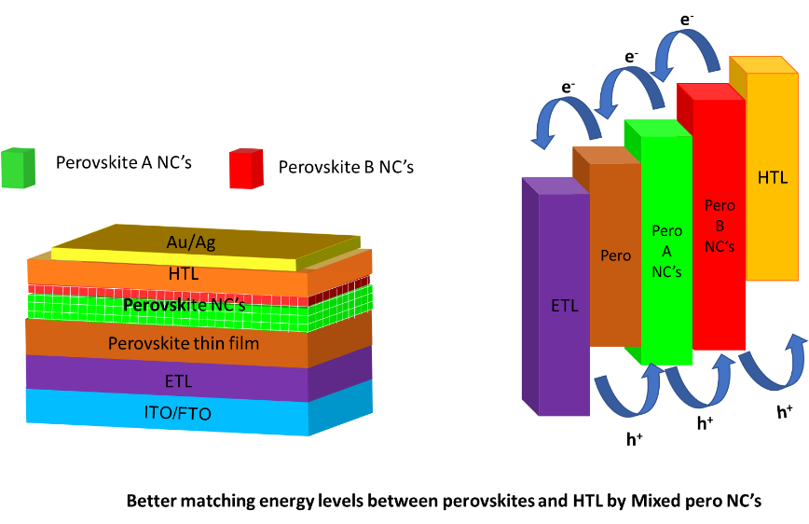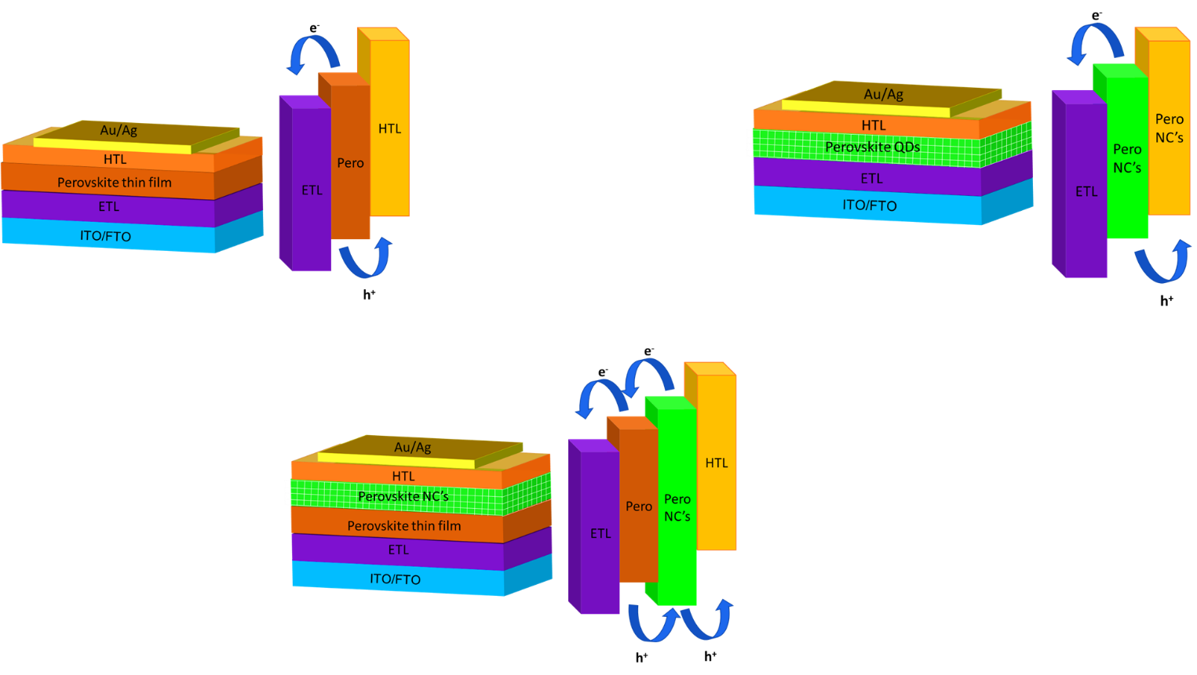
Hybrid perovskite heterojunction solar cell
Figure 4

Interfacial engineering in solar cells:
Need to focus on improving fabrication by utilizing addition interfacial layers for better matching energy levels between perovskites and HTL by mixed perovskite NC’s to obtain efficient devices with high PLQY and PCE. By using the QDs, better matching of energy band gap between HTM and the active layer can be aligned and which results in high carrier mobility therefore hysteresis of the device is reduced drastically. So, the efficiency of the device can be improved by introducing PeQDs in the conventional perovskite thin film solar cell.

Interfacial engineering in perovskite quantum dot LEDs:

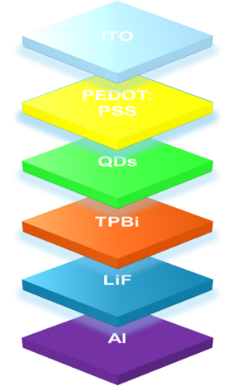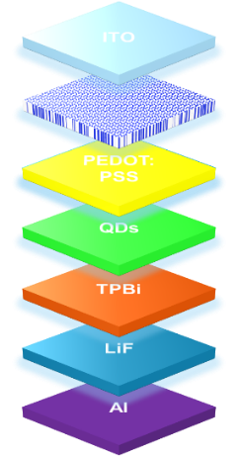

The schematic architecture of a QDLED device. The schematic architecture of a QDLED device with nanostructures
Figure 5

The development of perovskite LEDs based on these QDs mitigates issues commonly found in LEDs based on perovskite films such as low flexibility due to thick active layers and large grain sizes, a limited device architecture due to very polar aprotic solvents used for deposition of the active layer, and a cumbersome fabrication process. As an alternative route to the fabrication of efficient perovskite LEDs, halide perovskite quantum dots (QDs) can be utilized in place of perovskite films. Perovskite QDs can be processed into thin solid films in nonpolar solvents and have shown enhanced PL properties, a broadened scope of device architecture, and promising device performance. Moreover, conventional inorganic QDs have been demonstrated to retain functionality upon mechanical deformation in flexible devices. In this regard, colloidal perovskite QDs are well suited for the fabrication of efficient future of flexible electronics and high-eﬃciency light-emitting diodes.

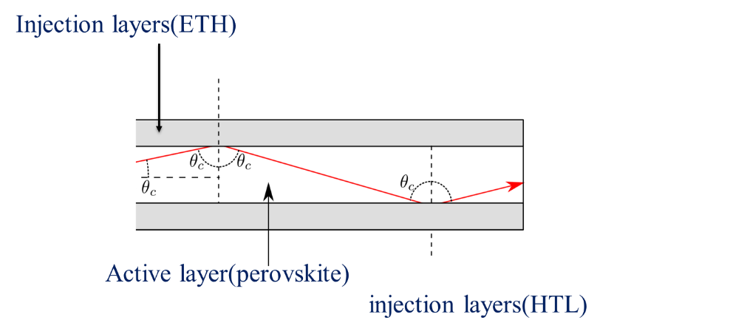
Figure 6
With the intension of obtaining high optical confinement difference between the refractive index of active perovskite layer and charge injection layer will become large so there will be chances for total internal reflection which leads to low light extraction efficiency
Then fabrication of perovskite quantum dot light emitting diodes (PeLEDs) with nanophotonic substrate or embedded nanostructure for outcoupling the waveguided light to decrease the interface reflections there by increase EQE. So, carrier and optical confinement can improve the PLQY and EQE to obtain highly efficient devices.

Processing of colloidal NCs to enhance electrical coupling between the NCs:
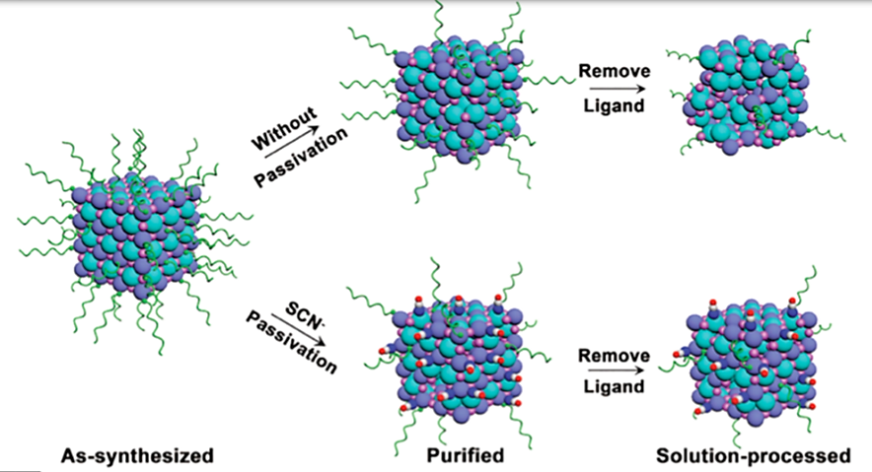

Figure 6[5]

HPNCs can be synthesize in organic solvents which are typically protected by long-chain aliphatic molecules like oleic acid (OA) and oleylamine (OAm). These hydrocarbon chains are electronically insulating. Limited short-circuit current density (J_{SC}) due to the presence of capping ligands that cause high electric resistance and act as potential barriers in QD-based optoelectronic devices. So, there is need to improve the electronic coupling between QDs, thus enhancing carrier mobility.
This limitation can be overcome through some techniques:
Solution-phase ligand exchange can be applied without additional tedious ligand removal processes during ﬁlm fabrication; however, the initial direct use of small inorganic ligands such as thiocyanate and metal chalcogenide complexes could be a path toward reducing the interparticle distance between colloidal perovskite NCs, with a minimal eﬀect on the NC-assembled ﬁlm morphology, as has been reported for conventional NCs.[25-27](figure 6). The thiocyanate treatment for PC-NCs has been an eﬀective approach for reducing trap states and maximizing performance by maintaining a stronger chemical interaction with the QD surface compared with that achieved by the longer oleic acid and oleylamine ligands.[28]

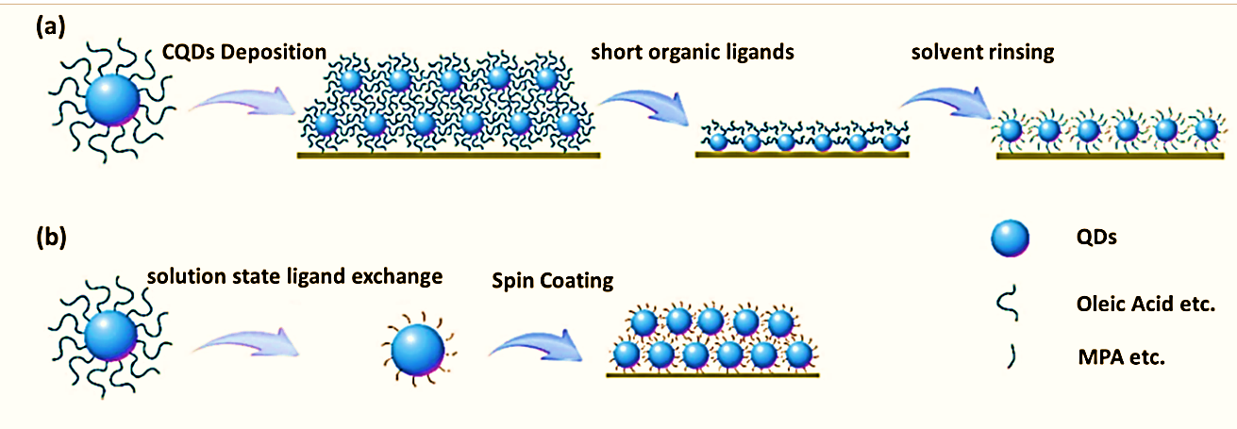

Figure 7

Post-treatment of the QD ﬁlm with a cation halide salt (AX treatment, where A = FA, MA or Cs and X = I− or Br−) (Figure 7 ) that tunes and greatly improves the electronic coupling between QDs. Short-chain ligand exchange methods are used for developing conventional QDs solar cells, toward reducing the resistance of the photo-active layer. The effect of the ligand type and length on the optical properties of PeQDs can be investigated. QDs capped with a halide ion pair (e.g., di-dodecyl dimethyl ammonium bromide (DDAB), di-dodecyl dimethyl ammonium chloride (DDAC)), and trioctylphosphine oxide (TOPO), octanoic acid, octylphosphonic acid (OPA), etc. a relatively short ligand that enables feasible carrier transport in the QD film and ultimately efficient utilization for PeLEDs application.
PeQDs passivated with short rigid ligands might be more optically stable due to the dense overcoating of the QDs, and could also advantageously influence the PeQLED performance by decreasing the potential barrier of the PeQD film after the ligand exchange process, compared to that of the as-synthesized PeQDs with long hydrocarbon tails. Ligand exchange experiments were carried out using ligands with different chain lengths, and it turned out that the solubility of the treated PeQDs in hydrophobic solvents could be dramatically modified depending on the ligand length. This was adjusted by tuning the ratio of the employed ligands and the polarity of solvents, which is essential to fabricate a nanocrystal film with high surface coverage, resulting in the superior performance of the PeQLEDs.
In the ligand exchange experiment with short chain ligands including aromatic acid/amine, the solubility of the treated PeQDs in hydrophobic solvents gradually decreased with an increase in the ratio of the short-chain ligands on the surface of the QDs. This indicated that the PeQDs with short-chain ligands became less sterically hindered than those with the original long-chain ligands, resulting in the precipitation of PeQDs when all the long alkyl chain ligands were exchanged with the short chain ones.
Octane was adopted as a key solvent, because aromatic acid/amine has a low solubility in octane, whereas the solubility of long alkyl chain ligands in it is quite high. This implies that it is difficult for short chain ligands to diffuse out into the solvent during the ligand exchange process and that the surface defects formed by the ligand dissociation can be minimized, thereby conserving the high photoemission property. In addition, benzene is essential to dissolve the aromatic short chain ligands such as Benzoic acid, or 4-Phenylbutylamine in our experiments in spite of its relative toxicity.
Branched capping ligands such as trioctylphosphine oxide (TOPO) are usually regarded as good capping ligands for improving the stability of NCs because they can provide strong steric effect. Because of the highly branched molecular structure and relatively strong coordination ability of P=O group, TOPO is featured by high stability against high temperature treatment and effective protecting effect originated from the strong steric effect.
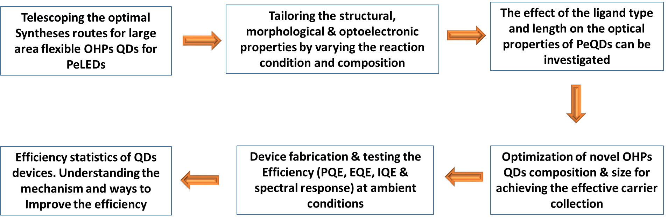
The overall methodology will be sequenced as above.

QDs ligand exchange and solution preparation:
- The patterned ITO-glass substrates were cleaned with deionized water, acetone, and isopropanol in sequence, followed by oven-drying and O₂ plasma treatment (FEMTO) for required time.
- The ligand-exchange strategy can be employed to tune the emission of QDs by exploiting possible mixed halide ion pairs.
- For high-efficiency perovskite light emitting diodes, there is the need of judiciously selected foreign ion into the PeQD’s matrix that could increase the defect formation energy, thus reduce the defect/trap states.
- Then fabrication of doped perovskite quantum dot light emitting diodes (PeLEDs) with nanophotonic substrate or embedded nanostructure for outcoupling the waveguided light.
- PEDOT:PSS was deposited onto the substrate by spin-casting and annealed for required duration in air.
- Colloidal OHPS ODs solution was spin-coated onto PEDOT:PSS to form the QDs layer. The remaining functional layers and aluminum electrodes were fabricated by thermal evaporation in a single run at a base pressure without breaking the vacuum.
- All the organics were evaporated at a specified rate and the aluminum electrodes were evaporated.
- A shadow mask was used to define the cathode. All devices were completed with rudimentary encapsulation in glovebox for characterization in air at room temperature.
- The PEDOT:PSS film here serves as the ITO modification layer to enhance the injection and transport of hole. The pure TPBi and B3PYMPM films serve as electron transport layer (ETL). The TPBi:Cs₂CO₃ and B3PYMPM:Cs₂CO₃ films serve as the n-type doped electron injection layer (EIL), which can enhance the electron injection and decrease the driving voltage effectively.
- PVK is used as a hole-transporting and electron-blocking layer while TPBi is employed as an electron-transporting layer. The PVK layer reduces the hole-injection barrier, blocks the electrons in the active layer, and hence allow the holes and electrons to recombine effectively in the QD emitting layer.
- All blended function layers were deposited using multisource coevaporation.
- Electron-Only, hole only Devices Control Devices Champion Devices were fabricated and studied for PeLED application.
Replacement of expensive organic HTMs with inorganic HTMs:
Use of inexpensive inorganic hole extraction layers such as NiO, CuI, Cs₂SnI₆, and CuSCN in the fabrication to obtain efficient devices[29, 30], since most widely used organic HTMs Spiro-OMeTAD and PTAA are expensive. So, it is one of the reasons that why perovskite QDs devices are not able commercialised.
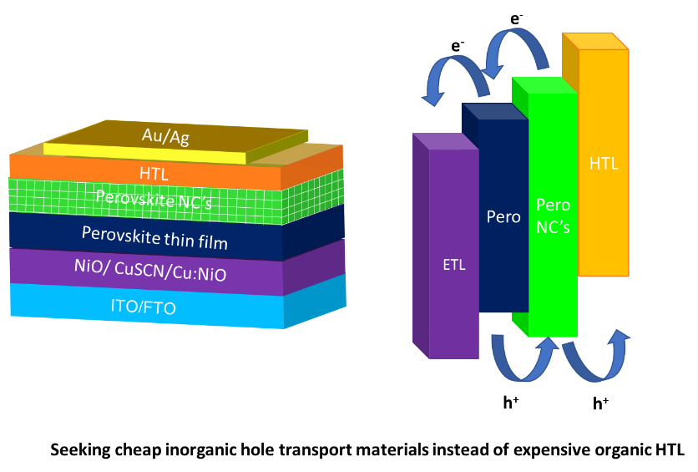

Figure 7

Scientific significance of the proposed work (Max 200 words):

With the possible strategy by replacing these long ligands on QDs (usually oleylamine (OAm) and oleic acid (OA)) with shorter ligands enables feasible carrier transport in the QD film and ultimately efficiency of the device can be improved without degrading or destabilizing the QD films.
The halide-exchange strategy can be employed to tune the emission of QDs by exploiting possible mixed halide ion to obtain different colours of QDs.
The defects, probably vacancies and/or distorted octahedra, could act as trapping centers of photogenerated carriers, thus giving rise to poor PLQYs for the band-edge emission. These defects form localized defects states (deep within the band gap) which trap charge carriers and leads to the formation of indirect band gaps so that non-radiative recombination will take place in the semiconductors, which inhibits the various optoelectronic processes. Hence the defect tolerant nanocrystals/QDs can be synthesised be doping appropriate element so the carrier confinement can be improved.
Followed by incorporating nanostructures in fabrication will decrease the interface reflections so that the optical confinement will be improved. By the dual confinement (carrier and optical) and replacement of long ligands by short ligands, high brightness and high EQE can be obtained.

Translational potential of the proposed work (Max 200 words):
By designing the suitable HPs QDs, we are looking forward to obtain the following properties.
- Facile low temperature solution-based fabrication technique.
- HPs QDs with flexible large area next generation electronics.
- HPs QDs with high absorption coefficient and long-term stability in air ambient.
- Research outcome of the proposed project can be used in the following industries
- Solar cell and LEDindustries: The current research unveils the potential for using the novel HPs QDs layers for highly efficient flexible next generation electronics. Upon successful incorporation of these HPs QDs in the small prototype cells, these prototypes would be used for module level production in the flexible electronics, leading to the establishment of the new such industries.
- Chemical companies: These novel HPs QDs which are robust, air stable and highly pure in nature will be useful for the semiconductor industries for various photonic applications that span from the lasing applications, photodiodes, photodetectors, sensing applications, X-ray detectors, etc.

Relevance of the proposed work to India (Max 200 words):

Prior expertise of the investigators related to the area (Max 200 words):
The Indian PI will design and develop the novel stable HPs QDs and studied its structural and optoelectronic properties. The photo physics of the developed material will be intensively investigated. With ligand exchange strategy the surface engineering of the developed QDs will be addressed to the PeLED application. With the short-chain ligand exchange methods are used for developing conventional QDs solar cells, toward reducing the resistance of the photo-active layer. The effect of the ligand type and length on the optical properties of PeQDs can be investigated. In order to improve the branched chain ligand can also be exchanged. The thickness and the size of the developed QDs was optimized for maximum PLQY efficiency. The J-V-L characteristics and the EL spectra of the LEDs were collected with an adhesive encapsulation in the dark room.
Based on measured parameters of the band structure, absorption coefficient and lifetime of electron-hole pairs, generated by light, we will estimate the influence of cesium doping and the role of mixed halide ions on the PLQE of HPs QDs with the aid of computer simulations. Above mentioned parameters of the perovskite slab should be measured before a final PeLEDs structure fabrication. This procedure will allow us to analyze various types of cesium doped PeLEDs and different halide ions with minimal expenses. Electronic properties can be predicted by theoretical stimulations. They can suggest the optimal architecture of photodetectors on the basis of the theoretical analysis. Band edge positions of semiconductors determine their functionality in many optoelectronic applications such as photovoltaics, photoelectrochemical cells and light emitting diodes. Quantum dots (QDs), can be tuned through surface chemistry modification. By combining experiments and ab initio simulations, we establish clear relationships between QD surface chemistry and the band edge positions of ligand/QD hybrid systems.

1. Baikie, T., et al., Synthesis and crystal chemistry of the hybrid perovskite (CH3NH3)PbI3 for solid-state sensitised solar cell applications. Journal of Materials Chemistry A, 2013. 1(18): p. 5628-5641.
2. De Wolf, S., et al., Organometallic Halide Perovskites: Sharp Optical Absorption Edge and Its Relation to Photovoltaic Performance. The Journal of Physical Chemistry Letters, 2014. 5(6): p. 1035-1039.
3. Zhang, Y., et al., Two-dimensional (PEA)2PbBr4 perovskite single crystals for a high performance UV-detector. Journal of Materials Chemistry C, 2019. 7(6): p. 1584-1591.
4. Ishii, A., A.K. Jena, and T. Miyasaka, Fully crystalline perovskite-perylene hybrid photovoltaic cell capable of 1.2 V output with a minimized voltage loss. 2014. 2(9): p. 091102.
5. El-Ballouli, A.a.O., O.M. Bakr, and O.F. Mohammed, Compositional, Processing, and Interfacial Engineering of Nanocrystal- and Quantum-Dot-Based Perovskite Solar Cells. Chemistry of Materials, 2019.
6. Leng, M., et al., Lead-Free, Blue Emitting Bismuth Halide Perovskite Quantum Dots. 2016. 55(48): p. 15012-15016.
7. Sum, T.C. and N. Mathews, Advancements in perovskite solar cells: photophysics behind the photovoltaics. Energy & Environmental Science, 2014. 7(8): p. 2518-2534.
8. Salim, T., et al., Perovskite-based solar cells: impact of morphology and device architecture on device performance. Journal of Materials Chemistry A, 2015. 3(17): p. 8943-8969.
9. Protesescu, L., et al., Nanocrystals of Cesium Lead Halide Perovskites (CsPbX3, X = Cl, Br, and I): Novel Optoelectronic Materials Showing Bright Emission with Wide Color Gamut. Nano Letters, 2015. 15(6): p. 3692-3696.
10. Liang, X., et al., Continuous low temperature synthesis of MAPbX3 perovskite nanocrystals in a flow reactor. Reaction Chemistry & Engineering, 2018. 3(5): p. 640-644.
11. Epps, R.W., et al., Automated microfluidic platform for systematic studies of colloidal perovskite nanocrystals: towards continuous nano-manufacturing. Lab on a Chip, 2017. 17(23): p. 4040-4047.
12. Akkerman, Q.A., et al., Tuning the Optical Properties of Cesium Lead Halide Perovskite Nanocrystals by Anion Exchange Reactions. Journal of the American Chemical Society, 2015. 137(32): p. 10276-10281.
13. Yong, Z.-J., et al., Doping-Enhanced Short-Range Order of Perovskite Nanocrystals for Near-Unity Violet Luminescence Quantum Yield. Journal of the American Chemical Society, 2018. 140(31): p. 9942-9951.
14. Sanehira, E.M., et al., Enhanced mobility CsPbI<sub>3</sub> quantum dot arrays for record-efficiency, high-voltage photovoltaic cells. 2017. 3(10): p. eaao4204.
15. Zolfaghari, Z., et al., Operation Mechanism of Perovskite Quantum Dot Solar Cells Probed by Impedance Spectroscopy. ACS Energy Letters, 2019. 4(1): p. 251-258.
16. Kim, Y., et al., Efficient Luminescence from Perovskite Quantum Dot Solids. ACS Applied Materials & Interfaces, 2015. 7(45): p. 25007-25013.
17. Jiang, Y., et al., Spectra stable blue perovskite light-emitting diodes. Nature Communications, 2019. 10(1): p. 1868.
18. Yang, K., et al., All-Solution-Processed Perovskite Quantum Dots Light-Emitting Diodes Based on the Solvent Engineering Strategy. ACS Applied Materials & Interfaces, 2018. 10(32): p. 27374-27380.
19. Dutta, A., R.K. Behera, and N. Pradhan, Solvent Polarity: How Does This Influence the Precursor Activation, Reaction Rate, Crystal Growth, and Doping in Perovskite Nanocrystals? ACS Energy Letters, 2019. 4(4): p. 926-932.
20. Parobek, D., et al., Exciton-to-Dopant Energy Transfer in Mn-Doped Cesium Lead Halide Perovskite Nanocrystals. Nano Letters, 2016. 16(12): p. 7376-7380.
21. Norris, D.J., et al., High-Quality Manganese-Doped ZnSe Nanocrystals. Nano Letters, 2001. 1(1): p. 3-7.
22. Pradhan, N., et al., An Alternative of CdSe Nanocrystal Emitters: Pure and Tunable Impurity Emissions in ZnSe Nanocrystals. Journal of the American Chemical Society, 2005. 127(50): p. 17586-17587.
23. Akkerman, Q.A., et al., Solution Synthesis Approach to Colloidal Cesium Lead Halide Perovskite Nanoplatelets with Monolayer-Level Thickness Control. Journal of the American Chemical Society, 2016. 138(3): p. 1010-1016.
24. Lau, C.F.J., et al., CsPbIBr2 Perovskite Solar Cell by Spray-Assisted Deposition. ACS Energy Letters, 2016. 1(3): p. 573-577.
25. Rodà, C., et al., O2 as a molecular probe for nonradiative surface defects in CsPbBr3 perovskite nanostructures and single crystals. Nanoscale, 2019. 11(16): p. 7613-7623.
26. Yang, H., et al., Building bridges between halide perovskite nanocrystals and thin-film solar cells. Sustainable Energy & Fuels, 2018. 2(11): p. 2381-2397.
27. Wang, G., et al., Colloidal Nanocrystals Fluoresced by Surface Coordination Complexes. Scientific Reports, 2014. 4: p. 5480.
28. Koscher, B.A., et al., Essentially Trap-Free CsPbBr3 Colloidal Nanocrystals by Postsynthetic Thiocyanate Surface Treatment. Journal of the American Chemical Society, 2017. 139(19): p. 6566-6569.
29. Chen, J. and N.-G. Park, Inorganic Hole Transporting Materials for Stable and High Efficiency Perovskite Solar Cells. The Journal of Physical Chemistry C, 2018. 122(25): p. 14039-14063.
30. Calió, L., et al., Hole-Transport Materials for Perovskite Solar Cells. 2016. 55(47): p. 14522-14545.

